Homework 5

Asiqul Hoque

Section 17 Lesson 1: Logical Comparisons and Precedence Rules

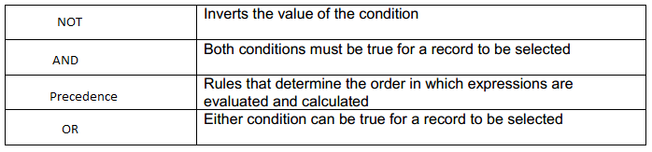

1. the first query uses AND where both conditions must be true for a record to be selected and the second query uses OR where either conditions can be true for a record to be selected.

2.SELECT last_name

FROM f_staffs

WHERE last_name LIKE '%e%' AND last_name LIKE '%i%';



3.SELECT last_name

FROM f_staffs

WHERE salary > 6.50 AND staff_type != 'Order Taker';

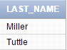

4.SELECT last_name

FROM employees

WHERE last_name LIKE 'D%a%e%' or last_name LIKE 'D%e%a';



5.SELECT loc_type

FROM d_venues

WHERE loc_type NOT IN('Private Home');

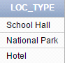

6. C

7.SELECT first_name, last_name

FROM employees

WHERE last_name LIKE '%en%' and salary < 8000 and hire_date BETWEEN '01-

JUN-98' AND '31-MAY-99';

*no data found

8.SELECT email

FROM employees

WHERE hire_date BETWEEN '01-JAN-96' AND '31-DEC-96' AND salary > 9000

AND commission_pct IS NULL;

*no data found